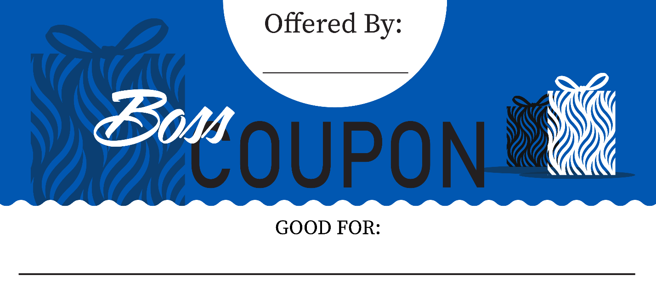
Example:
Noelle J.
ONE DAD JOKE

Instructions:
- Download document.
- Open document in Microsoft Word.
- Click inside the text boxes to edit text.
- Add a name and offer in the designated text boxes.
- Save as a PDF and send to your wonderful boss!

Name Here
COUPON OFFER HERE
Name Here
COUPON OFFER HERE
Name Here
COUPON OFFER HERE

